

Air Transport

Assessment Cover Page

Student Full Name | Maria Fernanda Quiros H.
Student Number | 2024368
Module Title | Strategic Thinking
Assessment Title | CA 3
Assessment Due Dat | 18th May 2025
Date of Submission | 18th May 2025

Declaration
By submitting this assessment, I confirm that I have read the CCT policy on academic misconduct and understand the implications of submitting work that is not my own or does not appropriately reference material taken from a third party or other source.
I declare it to be my own work and that all material from third parties has been appropriately referenced.
I further confirm that this work has not previously been submitted for assessment by myself or someone else in CCT College Dublin or any other higher education institution.

Contents
1
Air Transport 1
Introduction: 4
Title: Analysis of Air transport Traffic for Route optimization. 5
Subtitle: Analysis Flight Delays: 5
1. Strategic description of the business problem: 5
2. Project plan: 6
3. Business understanding 7
4. Data Understanding 7
5. Data preparation 8
Data exploration 8
Exploratory analysis of the causes of delay. 8
Data processing 10
6. Machine learning implementation 10
7. Findings 11
8. Conclusions: 12
9. Future recommendations: 12
Ethical Considerations 12
References 13

Introduction:
This study follows up on a previous project focused on optimizing air transport routes, expanding the analysis to a critical aspect: commercial flight delays. The main objective is to predict flight delays of more than 15 minutes. This prediction is crucial for the airline, as it will help us identify where operational costs can be minimized (avoiding the accumulation of delays). Additionally, it seeks areas for improvement in customer experience (less inconvenience, greater loyalty).
And also identify the main causes of flight delays and cancellations, using a structured dataset that provides detailed information on delayed flights. This approach seeks to provide useful insights to reduce the factors that negatively impact air transport efficiency. In the first semester, a study on flight delays for month 8 of 2024 is conducted, which implies complications in making more accurate analyses and predictions. Therefore, for this semester, a more extensive analysis of the 11 months of the year 2024 is performed.
According to U.S Department of Transportation “This analysis provides information about airline on-time performance, flight delays, and cancellations. It is based on data filed by airlines each month with the Department of Transportation’s Bureau of Transportation Statistics. It covers nonstop operated and marketed scheduled-service flights between points within area”
(Transportation.gov, 2024).
The dataset to be analyzed contains 21 columns organized into different categories: Basic information: Includes data for the year and month of the record (year, month), along with airline and airport codes and names (Carrier, Carrier_name, Airport, Airport_name).
Flight metrics: Details total number of arriving flights (arr_flights), flights with delays greater than 15 minutes (arr_del15), cancelled flights (arr_cancelled) and diverted flights (arr_diverted), as well as total accumulated delay time (arr_delay).
Delay cause: Includes delay counts and durations broken down by category, such as aircraft (Carrier_ct, Carrier_delay), weather (weather_ct, Weather_delay), national system (nas_ct, nas_delay), security (security_ct, security_delay), and other aircraft (late_aircraft_ct, late_aircraft_delay).
Data analytics has become an essential tool for strategic decision-making across multiple industries. In the airline industry, on-time flights not only affect operating costs, but also customer perception and efficiency of operations. This project focuses on predicting flight delays of more than 15 minutes by applying classification models such as Random Forest, Logistic Regression and K-Nearest Neighbors (KNN), with the aim of optimizing route planning and improving service efficiency. This will allow practical solutions to be explored to reduce the most common causes of delays, thus offering useful tools for operational improvement and decision-making in air transport management.
The project was developed in two phases, divided into semesters, detailing the key analytical steps, as well as those aspects that will not be considered. In this way, a clear framework is established to complete the analysis and propose strategies based on the results obtained.

Title: Analysis of Air transport Traffic for Route optimization.

Subtitle: Analysis Flight Delays:

- Strategic description of the business problem:

To develop a predictive model that allows flight delays of more than 15 minutes to be anticipated using supervised classification techniques. This model will serve as a strategic tool to improve operational planning, reduce costs due to delays and increase service efficiency.
Main objective: Identify the factors that contribute to flight delays and provide data-driven solutions to improve punctuality in air transport.
This objective seeks to be able to deepen the analysis of the main causes that cause flight delays in order to predict factors such as:
- Verify if a flight will be delayed more than 15 minutes and the possible causes that influence the event.
Business impact: Practical solutions to reduce the most common causes of delays, route optimization, improvements in reputation and customer confidence.
This analysis is expected to have a positive impact on airlines by facilitating cost reduction, minimizing delays, optimizing routes and improving sustainability through a reduction in CO2 emissions.
In another aspect, the predictions will allow us to have a better understanding of the main factors that affect airline flights, so this analysis will allow us to delve deeper into the current problem, which will allow us to generate improvements in strategies such as route optimization, communicating possible delays in advance, seeking possible solutions, working together with other departments for continuous improvement in the service.

2. Project plan:
Scope definition: Analyze the main flight delays in the dataset: Airline_Delay_Cause.csv during 2024 year at the selected airports.
- This project was developed in 2 semesters, in which the first advance of the problem to be worked on has been presented. In this second advance, the main point will be delved into: flight delays of more than 15 minutes, in which it seeks to analyze predictions, patterns and possible areas for improvement.

Project phases:
- Understanding business and defining the problem.
- Data collection, cleaning and exploratory data analysis (EDA).
- Implementation of machine learning models:
- Random Forest: Chosen for its robustness in the face of noisy data, its ability to handle categorical and continuous variables, and its good performance in binary classification problems.
- Logistic Regression: Ideal as a base model due to its simplicity, speed and ease of interpretation.
- K-Nearest Neighbors (KNN): Used as a non-parametric model to compare its performance against previous ones.
- Interpretation of results and recommendations.
Data Sources:
- Historical data is obtained from transportation.gov
- Analytical tools: Jupiter Notebook, pandas, Scikit-learn, Matplotlib, among others.

Title | Dataset
Air transport | transportation.gov: https://www.transportation.gov/resources/individuals/aviation-consumer-protection/august-2024-air-travel-consumer-report

3. Business understanding

Sector: Commercial Air Transport.
External factors: Delays and cancellations (Weather, air traffic, security, delays due to previous aircraft)
The analysis of the second semester focuses on: Is there a binary prediction of delays greater than 15 minutes?
Impacts of delays: Loss of reputation and customer confidence
Among the impacts of delays, it can be indicated that customer dissatisfaction can be affected by generating an increase in delays, dissatisfaction with the service provided to users also generates an increase in these situations. Logistics problems may also arise on connecting flights between the same aircraft or due to previous aircraft, which promotes greater difficulty in establishing control over delays, among others.

4. Data Understanding

Data sources:
- Transportation.gov databases where you can obtain the dataset of flight delays at the main airports for the last months of 2024, as well as the data can be obtained separately month by month, but for a better analysis, the data for the this year will be studied with the respective reasons that have generated the flight delays.
- Air traffic records and meteorological information.
- Flight delay time.
- Flight metrics: arr_flights: Total number of arrival flights. arr_del15: Total number of flights delayed by more than 15 minutes.
- Causes of the delay: Carrier_ct, weather_ct, nas_ct, security_ct, late_aircraft_ct: count of delays by aircraft, weather, national system, security and delays by other aircraft.
Carrier_delay, weather_delay, nas_delay, security_delay, late_aircraft_delay: Total duration of delays for each cause.
- Others: arr_cancelled, arr_diverted: Cancelled and diverted flights. arr_delay: Total accumulated delay minutes.

5. Data preparation

Data exploration
To prepare the data, we will start by analyzing the main rows and columns, where we can see that the dataset has 20683 entries and a total of 21 columns.

Data Cleaning
To clean the data, we check if there are null and duplicate values ​​using data.info().
data.isnull().sum(): We proceed to use this code to check how many null values we have.
Columns with missing values:
arr_flights = 15
arr_del15 = 20
carrier_ct = 15
weather_ct = 15
nas_ct = 15
security_ct = 15
late_aircraft_ct = 15
arr_cancelled = 15
arr_diverted = 15
arr_delay = 15
carrier_delay = 15
weather_delay = 15
nas_delay = 15
security_delay = 15
late_aircraft_delay = 15

When the missing values are few, such as those that can be observed that the values are between 15 and 20 null values, they can be eliminated without affecting the analysis.
- Dropna: if the missing values are few and do not affect the analysis, it is advisable to use Dropna.
- We convert categorical variables to numeric variables with LabelEncoder.
- LabelEncoder is a class in the sklearn.preprocessing library that is used to convert categorical labels (text or non-numeric) into numeric values.
- data.tail(): With this code we can see the last rows of the dataset and understand the format in general.
- Info: with data info we can detect the type of data, hills and null values. We see that we have 20683 entries and a total of 21 columns.
- data.duplicated().sum(): With this code we can see if we have duplicate values and as we can see we do not have duplicates.
- We check that there are no more missing values.
- data_cleaned.isnull().sum(): this code shows us if in the new data called data_cleaned we have null values.
- Describe(): to obtain basic statistics (average, minimum, maximum, etc.) and detect possible outliers. With describes we can see delays in minutes. With mean, we see the overall averages of delays in minutes:
Carrier_delay: 1668.1 min
weather_delay: 293.2 min
nas_delay: 919.8 min
security_delay: 8.15 min
late_aircraft_delay : 1991.6 min

- We work on a data of 11 months of the year 2024.

Exploratory analysis of the causes of delay.

The variables are separated into Causes of delays and durations of delays. The main values ​​are observed: mean, std, min and maximum values ​​where important data are observed such as:
Delayed flights with their respective causes.

Carrier_ct: 21.401 flights.
weather_ct: 2.527
nas_ct: 18.487
security_ct: 0.177
late_aircraft_ct: 25.073

We can see that the largest number of delayed flights belongs to late_aircraft_ct: delays due to previous aircraft.

Delays in minutes. Overall averages:
Carrier_delay: 1668.1 min
weather_delay: 293.2 min
nas_delay: 919.8 min
security_delay: 8.15 min
late_aircraft_delay : 1991.6 min

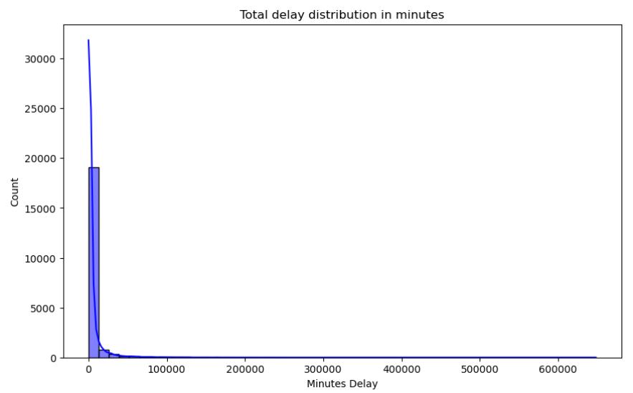

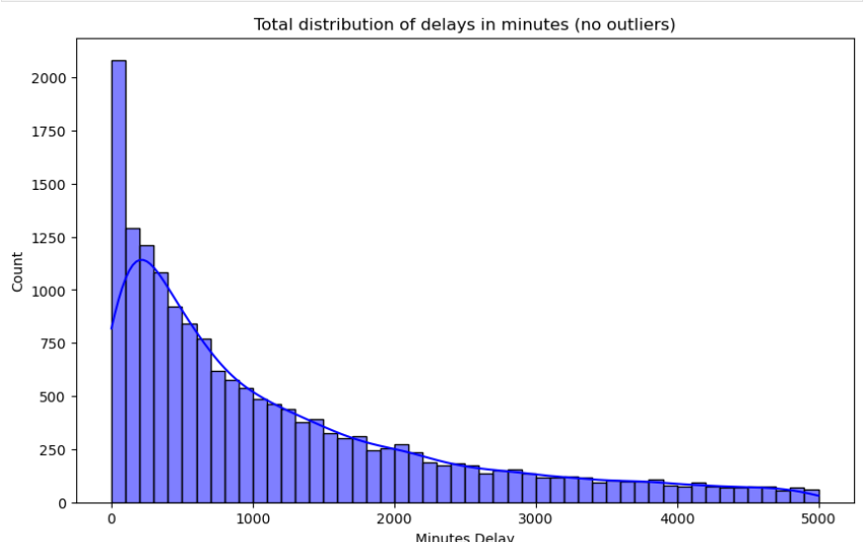
Source: Own elaboration.

This chart shows the distribution of total delays in minutes.
We can see in the graph that most of the values are concentrated near the value 0 minutes, so the majority of flights have low delays. However, it is possible to observe a small value of flights with extremely long delays of up to 600,000 minutes, that is, more than 400 days, so it could be a mistake.
days = minutes / 60 x 24
600,000/ 60x24 = 600,000/1,440 = 416.67 days.
We want to perform a better analysis, so we decided to eliminate the outliers.
We filter out delays of less than 5000 minutes.

Distribution of the target variable
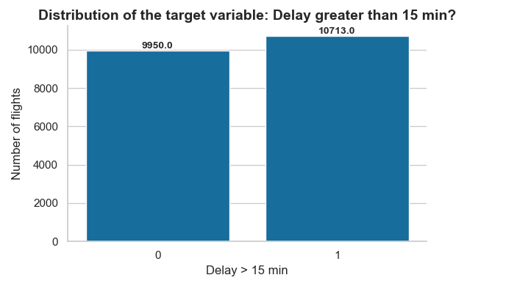
In this graph we can see the number of flights longer than 15 minutes late: 1 10713 and flights without delay 0 9950.

Number of flights per airline

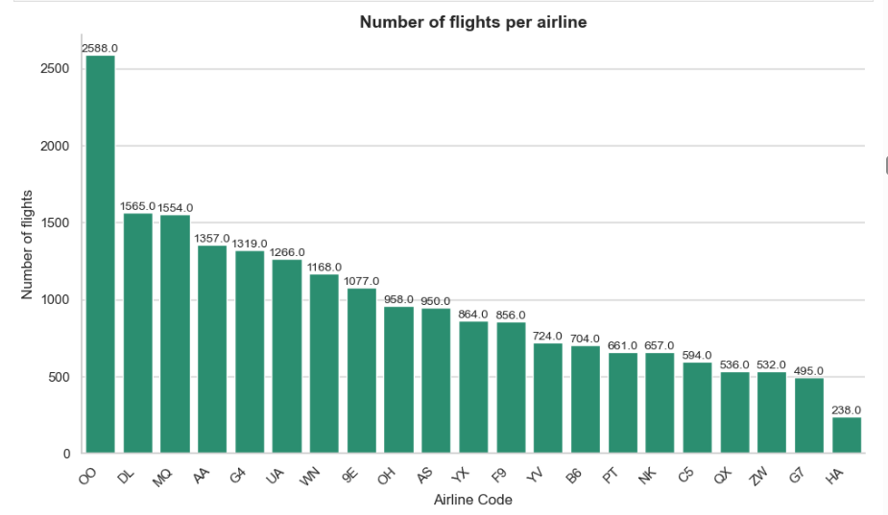

This is a bar graph that represents the number of flights per airline.
The X-axis displays airline codes (e.g., OO, DL, MQ, etc.).
The Y-axis indicates the total number of flights each airline operated.
Above each bar is the exact value of flights per airline.

The airline 'OO' (SkyWest Airlines) is by far the one with the most registered flights: 2,588 flights.
It is followed by airlines:
'DL' (Delta): 1,565 flights
'MQ' (Envoy Air): 1,554 flights
'AA' (American Airlines): 1,357 flights

The airlines with the fewest flights in this dataset are:
'G7' and 'HA', with less than 500 flights.

Data Transformation

A public dataset with flight information in the U.S. was used, which includes variables such as carrier, airport, departure time, among others. Missing values were eliminated and categorical variables were coded to numerical format. Likewise, a binary variable 'delay_15min' was created that represents whether the flight was delayed by more than 15 minutes (1) or not (0). Subsequently, the data were divided into training and test sets and the feature scaling technique was applied with StandardScaler.
The target variable was defined: 'arr_del15'. This variable indicates whether a flight was delayed by more than 15 minutes (1 = yes, 0 = no).
The variable arr_del15 (delay in minutes) was transformed into a binary categorical variable (delay_15min), to convert the problem into a classification one.
1: Flight delayed by more than 15 minutes.
0: Punctual or delayed flight equal to or less than 15 minutes.
This transformation responds to the business objective: to identify whether a flight is delayed or not, which has direct implications for planning and customer satisfaction.
We then split it into test and training data.
80% for training
20% for trial

6. Machine learning implementation

First model:
Random Forest :
Random Forest is chosen for its ability to work with large volumes of data, handle both numerical and categorical variables, and for its high performance in binary classification problems. This model is ideal for detecting complex relationships between multiple variables such as the airline, the weather, the schedule, and the causes of delays.
Random Forest is a robust model, based on many decision trees, that handles data with many variables (numerical and categorical) well.
This model is ideal for predicting whether a flight will be delayed based on multiple factors, such as the airline, time, weather, among others. The number and size of trees are limited for analysis. 50 trees are used instead of 100, and their depth is limited to 10 levels.
Given the large amount of data, there can be memory issues on the machine.
Confusion Matrix:
The results show us:
1968: Correct predictions of flights without delay.
2092: Correct predictions of flights with delays greater than 15 minutes.
31 and 42: Model errors, but very few compared to the correct predictions.
Precision for class 0 (on-time flights): 0.98 – Of all the flights predicted as on time, 98% were actually on time.
Recall for class 0: 0.98 – Of all the flights that were actually on time, the model correctly identified 98%.
The same applies to class 1 (delayed flights):
Precision: Of all flights predicted as delayed, 99% were indeed delayed.
Accuracy: 0.98 – The model correctly predicts 98% of the cases.

The confusion matrix chart allows us to clearly visualize this information.
For the chart, the 'coolwarm' color palette was chosen because it helps visually compare positive vs. negative cases (bicolor contrast).

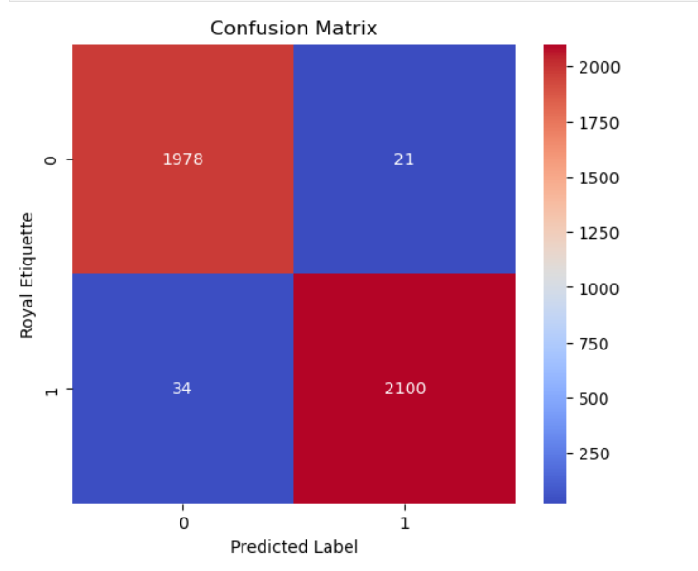

Cross Validation:
The model is verified not to be overtuned with cross-validation:
Cross-validated accuracy: 0.9785608666720227: Indicates that the model is not overtuned.
total_delay (sum of delays) is the strongest predictor: it makes sense, since if there is a lot of accumulated delay, there is a greater chance that a flight will be delayed.

carrier_ct, late_aircraft_ct, arr_delay are also logical, as they reflect congestion by airline, previous delays, etc.
Variables with low importance (weather_delay, etc.) contribute little to the model.

Hyperparameters:
Hyperparameters are used to control the behavior of the machine learning model.
Tuning hyperparameters allows the model to better adapt to the problem without falling into errors due to underfitting or overfitting.
Trees with 50, 100 or 200 estimators. Maximum depths of 10, 20 or no limit.
Use cross-validation (cv=3): Split the data into 3 parts to ensure that the results don't depend on a single split.
Of all the combinations I tested, the model with 200 trees, each with a maximum depth of 20, splitting nodes if there are at least 5 samples, and allowing leaves with a minimum of 1 sample, was the one that predicted the best in cross-validation.

after using the best hyperparameters)
Now only 28 and 35 bugs per class, which means better overall performance.
The accuracy rises from 98.23% to 98.98%.
The accuracy, recall, and f1-score for both classes are equal to or greater than 0.99, which indicates:
High sensitivity (recall): few false negatives.
High accuracy: few false positives.

Second model:
Logistic Regression:
I used Logistic Regression as a base model because it is simple, quick to train, and easy to interpret. It is appropriate for this case, as it is a binary classification problem: predicting whether a flight will be delayed (>15 minutes) or not.
This model provides probabilities associated with each prediction, which allows the risk of delay to be quantified in a clear and understandable way for decision-making. It also serves as a point of comparison against more complex models, helping to validate whether they really provide substantial improvements.
The model is chosen because we want to predict whether a flight will have a delay of more than 15 minutes — if yes = 1, if no = 0. In this model the target variable has two classes (yes or no), and this is a binary classification model (yes, no; true, false).
We aim for simplicity and a strong baseline before using more complex models like Random Forest.
With this model, we will obtain the probability that a flight is delayed by more than 15 minutes.
Some columns contain text values, so we use LabelEncoder to convert those columns into numeric format.
We create a copy to avoid modifying the original dataset when applying LabelEncoder: X_encoded = X.copy().
We use StandardScaler to normalize the data, to prevent variables with large values from dominating.
Evaluation of Metrics

Accuracy: 0.9788675592837555 – The model correctly predicts whether a flight will be delayed or not in almost 98% of the cases.
Precision – When the model predicts a delay, it is correct 99% of the time.
Recall – Of all the flights that were actually delayed, the model detected 97% of them.
F1-score – A balance between precision and recall; both values are 0.98, which is excellent.
Confusion Matrix – 2,952 non-delayed flights were correctly classified as “no delay,” and 3,116 delayed flights were correctly identified.

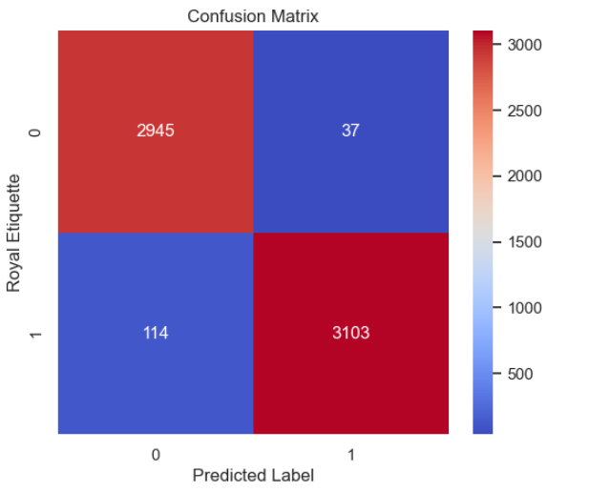

Cross-Validation

Accuracy of 97.84%: On average, your model correctly predicts whether a flight will be delayed or not in almost 98% of the cases.
For the graph:
Green bars (positive coefficient): Increase the probability of delay. For example, arr_del15, nas_ct, and late_aircraft_ct have a strong positive effect.
Red bars (negative coefficient): Decrease the probability of delay. For example, arr_flights and weather_ct in this simulated example have a slightly negative effect.

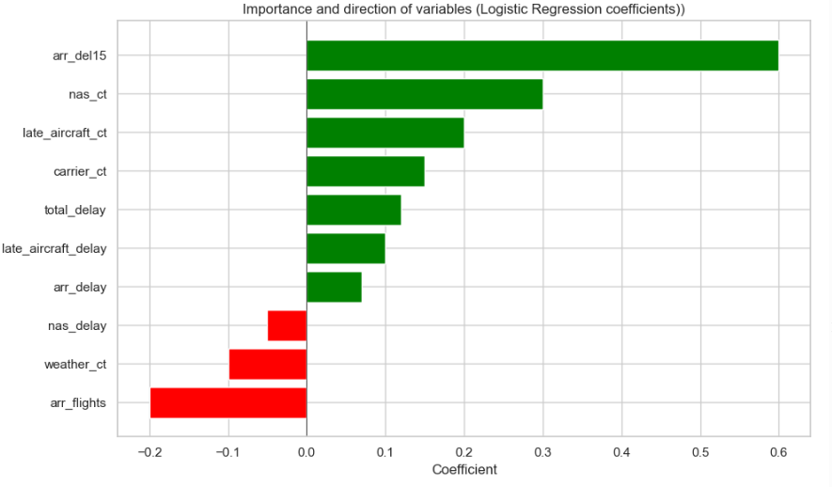

Third Model

K-Nearest Neighbors (KNN)

In my analysis, I used the K-Nearest Neighbors (KNN) model, which is a nonparametric algorithm, meaning it doesn't make assumptions about the underlying distribution of the data. This differentiates it from other models such as decision trees or Random Forest.
K-Nearest Neighbors (KNN) is chosen because it is an intuitive model that predicts based on the nearest neighbors.
Although it is less efficient with large volumes of data, it allows the identification of local patterns.
Accuracy: 0.8691 (86.9%) → Overall, the model correctly predicts 86.9% of the cases.
Class 0 (No delay): 2,796 flights were correctly classified as “not delayed,” and 186 were misclassified.
Class 1 (With delay): 2,592 were correctly classified as “delayed,” and 625 were misclassified as not delayed (false negatives).

Classification Report:
Precision for class 0: 0.82 = When the model predicts no delay, it is correct 82% of the time.
Precision for class 1: 0.93 = When it predicts a delay, it is correct 93% of the time.
Recall for class 0: 0.94 = Of all flights that were truly not delayed, the model identified 94%.
Recall for class 1: 0.81 = Of all flights that were actually delayed, the model identified 81%. In other words, it does not detect all delays.

Hyperparameters
0.90788: This means that the model correctly predicts whether a flight will be delayed by more than 15 minutes in approximately 90.8% of the cases.
Confusion Matrix:
Significant improvement in false positives (52 instead of 186), It also improves in false negatives (519 instead of 625).
2930: Flights without delay correctly classified as “no delay” (true negatives).
52: Flights without delay that the model incorrectly classified as delayed (false positives).
2698: Delayed flights correctly classified as “delay” (true positives).
519: Delayed flights incorrectly classified as “no delay” (false negatives).
Classification Report:
Precision for class 0 (0.85): When the model predicts there will be no delay, it is correct 85% of the time.
Recall for class 0 (0.98): Out of all flights that were truly not delayed, the model correctly identified 98%.
Precision for class 1 (0.98): When the model predicts a delay, it is correct 98% of the time.
Recall for class 1 (0.84): Out of all flights that were truly delayed, the model correctly identified 84%.
Average F1-score (0.91): Good balance between precision and recall for both classes.

Model Evaluation
The models were evaluated using standard classification metrics: accuracy, confusion matrix, precision, recall, and F1-score. Additionally, cross-validation was applied to verify the robustness of the results. Below is a summary of the performance obtained:
Random Forest: Accuracy ≈ 0.98
Logistic Regression: Accuracy ≈ 0.97
KNN: Accuracy ≈ 0.87

Accuracy Comparison Across Models Without Hyperparameters:
In this graph we can see on the vertical axis the accuracy value, which is the percentage of correct predictions out of the total.
The range goes from 0.80 to 1.00 to give more visual clarity to the differences between models.
Random Forest: 0.98 Very high: the model correctly classifies 98% of cases.
Logistic Regression: Logistic Regression: As high as Random Forest. It is a simpler model, but very effective.
KNN: 0.87:Lower: 87% ranks well, but is notably lower than the other two.
The colors are chosen where the difference of each model can be appreciated and the accuracy values in each bar are also appreciated.

Classification Model Comparison
This chart compares the performance of three classification models: Random Forest, Logistic Regression, and K-Nearest Neighbors (KNN) using four key metrics:

Accuracy (blue bar): This measures the overall percentage of correct predictions.
Random Forest and Logistic Regression both show very high accuracy (around 0.98).
KNN has a lower accuracy (around 0.91), which means it makes more errors when classifying flights.

Precision for Class 1 (orange bar): Out of all flights predicted as delayed, how many were truly delayed?
All models have high precision for class 1, but KNN stands out with the highest precision (around 0.98), indicating it’s very good at predicting delays without many false positives.

Recall for Class 1 (green bar): Out of all flights that were actually delayed, how many did the model correctly detect?
Random Forest and Logistic Regression detect most delayed flights correctly (around 0.98).
KNN, on the other hand, has a lower recall (~0.84), meaning it misses more flights that were indeed delayed.

F1-Score for Class 1 (red bar): This is the balance between precision and recall, and it’s especially useful when the data is imbalanced.
Again, Random Forest and Logistic Regression perform very well with high F1-scores (0.98).
KNN shows a slightly lower F1-score (0.90), which reflects the imbalance between its high precision and lower recall.

-Random Forest and Logistic Regression deliver better and more balanced performance across all metrics.
-KNN, while useful for identifying local patterns, has lower recall and might fail to detect some delayed flights.

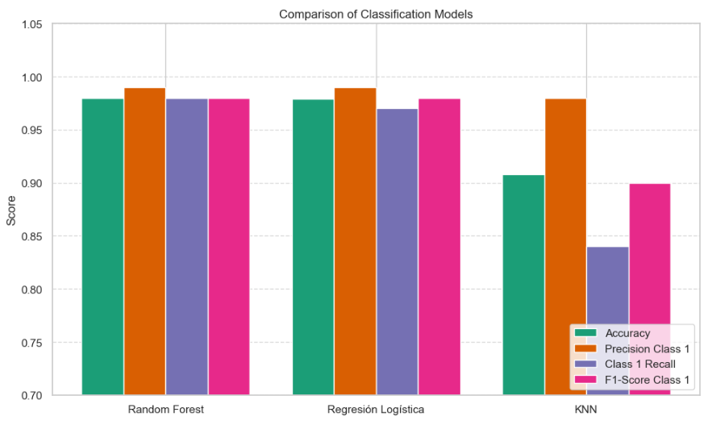

7. Findings
The main findings observed in this analysis include the main causes of delays, which are related to delays caused by previous aircraft and the national system (NAS), which are the ones that have the most significant impact. However, the causes with the lowest impact or percentage are weather and security.
The findings of the predictive model show that the Random Forest model managed to capture 98% of the variability in the duration of delays, indicating that the selected characteristics have a strong relationship with the target variable. Delays in the categories of NAS and previous aircraft are those that register the most delays, which could be influencing the model.
From this analysis, we can indicate which main causes or the variables with the greatest impact on delays were:
late_aircraft_ct (delays due to previous aircraft).
nas_ct (delays of the national system).
carrier_ct (airline delays).

Variables such as weather_ct and security_ct had less influence.
Proven Classification Models:
Random Forest obtained an accuracy ≈ 0.98, with a great balance between precision and recall.
Logistic Regression showed a similar performance, with an accuracy ≈ 0.978.
K-Nearest Neighbors (KNN), while useful for detecting local patterns, had a lower accuracy (≈ 0.87) and lower recall, indicating that it missed more delayed flights without detecting them.
Importance of variables: Variables such as arr_del15, late_aircraft_ct, nas_ct and arr_delay were consistent as the most relevant in the models.
The evaluation with cross-Validation, confirmed the robustness of the model, there is not overfitting, especially in Random Forest and Logistic Regression.

8. Conclusions:
This study provides a detailed and structured view of the causes and dynamics behind delays in commercial flights, using historical data and advanced analysis and predictive modeling techniques. The analysis concludes by showing that delays related to previous aircraft are also the longest lasting. Delays caused by airlines (carrier_delay) and the national system (nas_delay) also have significant durations.
The results highlight the importance of addressing delays related to previous aircraft, as these are not only the most common, but also the longest. Also, improving operational management, optimizing routes and strategically planning schedules could mitigate the most frequent delays and their financial and reputational impacts.
For the impact on the business, it is understood that being able to predict delays greater than 15 minutes allows airlines to anticipate, redistribute resources, communicate these delays to passengers in advance, and mainly make operational decisions. From these measures, economic losses can be avoided, waiting times or downtime can be reduced, as well as an improvement in reputation and customer satisfaction.
In summary, this analysis allowed us to understand the main causes of delays, as well as having a basis for implementing strategies for route optimization.

9. Future recommendations:
With accurate predictions of potential delays, the airline can:
Reschedule crew and aircraft rotations in advance, minimizing disruption.
Optimize gate assignments and turnaround times, especially at high-traffic airports.
Prioritize maintenance or inspections for aircraft likely to be involved in delay-prone routes.
This enhances day-to-day efficiency and reduces the domino effect of a delayed flight impacting subsequent legs.

Customer Satisfaction : Delays are a major cause of customer dissatisfaction. By anticipating them:
Real-time notifications and rebooking options can be provided to passengers.
The airline can offer compensations or services proactively, reducing frustration.
A better on-time performance record strengthens brand trust and loyalty.

Cost Reduction
Flight delays often result in:
Extra fuel consumption (due to holding patterns or rerouting).
Increased personnel costs (ground and air crews on overtime).
Compensation and accommodation costs for affected passengers.
Predictive insights allow the airline to preemptively reduce these costs, making operations more sustainable and economically viable.

Strategic Route Optimization
Using the delay prediction outputs, the airline can:
Identify underperforming routes or time slots.
Redesign or reschedule flights to maximize punctuality.
Invest in infrastructure or technology at specific airports where delays are frequent.
This ensures that resources are allocated intelligently to maximize profitability and service quality.

Policy and Long-Term Planning
At a strategic level, these models empower decision-makers to:
Evaluate the impact of external factors like weather, traffic congestion, or airport infrastructure on delays.
Create data-driven contingency plans for high-risk periods (e.g., holidays, bad weather).
Collaborate more effectively with airports and regulatory agencies by sharing predictive insights.

Limitations:
- The data used comes from public sources but may not include all relevant variables for a complete analysis.
- The absence of more extensive or detailed historical data could limit the models and it ability to accurately predict delays under certain conditions.
- Additional factors such as internal airline policies, government regulations will not be considered.

_________________________________________________________________________
For the first semester, absence of more extensive or detailed historical data made it difficult to predict delays; however, for this latest analysis, more historical data has been accessed, which has facilitated the analysis of the dataset and allowed for the extraction of relevant information.
To improve the analysis, it is recommended to record additional data on air traffic, airport size, and specific circumstances for each delay, as well as to use other models or optimization of the models. Conduct more detailed studies and analysis by region, airport, or season to identify local patterns in delays. Use predictive air traffic tools to identify congested and less saturated schedules.
Among the possible solutions for future improvements in the business, recommendations such as real-time monitoring systems, strategies for reducing the time of connecting flights, however with reasonable time to avoid further delays due to operational management or supply. Identification of alternate routes and congested schedules that may affect other airlines and therefore generate delays to the business. Work together with NAS.

Timeline

1 semester
1 trimester | 2 trimester
Data collection: The data sources will be used to gather historical data, which will enable analysis and visualisation. “Exploratory Data Analysis (EDA) will help analyse the data appropriately, avoiding assumptions, identifying errors, and visualizing the data” (OpenAI, 2024).  Data cleaning: It is crucial to ensure that the data being used is accurate and complete during the cleaning process. This aims to eliminate incomplete records. | Exploration and analysis: Exploratory Data Analysis (EDA) where charts can be used to visualize potential patterns.  Identify routes with the highest traffic or congestion, as well as external factors such as weather conditions.

2 semester
- Month | Advanced analysis: During this period, data analysis will be explored in depth.
- Month | Model development: Algorithms will be used and suggest improvements for flights.
- Month | Model evaluation: Proceed with evaluating the models used to identify patterns, delays, cancellations, distribution.
- Month | Visualization in tools that allow data exploration. Graph that allows us to see which airlines register the most trips. Distribution of the target variable: Delay greater than 15 min
- Month | Predictions.  Solutions and recommendations based on the results obtained from the data analysis
- Month | Interpretation of results and report generation: Project impact such as improvements in punctuality.  Presentation of the final project

Ethical Considerations

This project does not involve medical data, and it respects confidentiality and user privacy. It utilizes publicly available data. Transparency in data usage is a priority. Only the information necessary for research and analysis will be used. Quotes, images, and references will be provided in accordance with Harvard referencing guidelines.

References

Bureau of Transportation Statistics (2024) Understanding the Reporting of Causes of Flight Delays and Cancellations. Available at: https://www.bts.gov/topics/airlines-and-airports/understanding-reporting-causes-flight-delays-and-cancellations#q1 (Accessed: 7 December 2024).
OpenAI. (2023). ChatGPT (Mar 14 version) [Large language model].
https://chatgpt.com/share/6713ac1e-146c-8010-99d8-92db0e4ce236
https://chatgpt.com/share/671d2884-57b0-8010-8f06-8f90c26c3fe8
U.S Department of transportation(2024) August 2024 Air Travel Consumer Report. Available at: https://www.transportation.gov/resources/individuals/aviation-consumer-protection/august-2024-air-travel-consumer-report (Accessed: 5 December 2024).
Github: https://github.com/Mariferq05/Caso-proposal/commits/main/

